# 

# Abstract

The "Create Pay-Slip" project is an innovative and user-friendly application designed to automate the process of generating accurate and comprehensive pay-slips for customer within the organization. The system aims to streamline the payroll management process, enhance efficiency, and reduce manual errors, ensuring timely and precise compensation to customer.

In conclusion, the "Create Pay-Slip" project aims to revolutionize the payroll management process, providing organizations with an efficient, accurate, and user-friendly solution for generating pay-slips.

This project represents a significant step towards optimizing HR processes and enhancing customer satisfaction within the organization.

ACKNOWLEDGMENT

I would like to express my very great appreciation to my supervisor Md. Monowar Hossain Assistant Professor, Dept. of CSE, BSMRSTU for his valuable and constructive suggestions during the planning and development of this project. His willingness to give his time so generously has been very much appreciated. Advice given by other academic lecturers has been a great help in complete in this project.

Secondly, I would like to thank my friends who helped me to make my work more organized  
and well stacked until the end.

Last but clearly not the least; I would like to thank The Almighty for giving me strength to  
complete my report on time.

Iftaker Siddique

20CSE036

July 2023

**Table of Content**

|  |  |  |
| --- | --- | --- |
|  | **Table of content** | Page No |
|  | Abstract | 1 |
|  | Acknowledge | 2 |
| **Chapter 1** | **Introduction** |  |
| 1.1 | Problem Statement | 5 |
| 1.2 | Objective(s) | 6-7 |
| **Chapter 2** | **METHODOLOGY** |  |
| 2.1 | Introduction | 8 |
| 2.2 | Features of proposed system | 8 |
| 2.3 | System Environment | 8 |
| 2.3.1 | Hardware Configuration | 8 |
| 2.3.2 | Software configuration | 9 |
| 2.3.2.1 | Code Blocks | 9 |
| 2.3.2.1 | GCC | 9 |
| 2.3.2.3 | Browser | 10 |
| 2.3 | Methods and Procedures | 10-11 |
|  |  |  |
| **Chapter 3** | **PROPOSED SYSTEM** | 12 |
|  | **Table of Content** | 12-15 |
| **Chapter 4** | **Test Plan** |  |
|  | Introduction | 16 |
| 4.1 | Unit testing | 16 |
| 4.2 | Integration testing | 16 |
| 4.3 | Function Testing | 16 |
| 4.4 | Performance testing | 17 |
| 4.5 | Compatibility testing | 17 |
| 4.6 | Localization Testing | 17 |
| 4.7 | User acceptance testing(UAT) | 17 |
| 4.8 | Regression testing | 17 |
|  | Results | 17 |
| **Chapter 5** | **Future work** |  |
| 5.1 | limitation | 18 |
| 5.2 | Future work | 19 |
| **Chapter 6** | **CONCLUSIONS** |  |
| 6.1 | Conclusion | 20 |

**CHAPTER 1**

# INTRODUCTION

In the digital age of retail, the convenience of shopping has reshaped the way customers interact with businesses. With the increasing popularity of e-commerce platforms and the growing number of customers making purchases from shops, it becomes paramount for businesses to ensure transparency, accuracy, and trust in their transactions. One essential aspect of this process is providing customers with detailed and comprehensive pay-slips for their purchases.

The "Pay-Slip Project for Shop-to-Customer" aims to address this crucial need by developing an advanced and user-friendly system that generates personalized pay-slips for every customer after each successful transaction. This project is designed to streamline the payment process, enhance customer satisfaction, and foster a sense of reliability and credibility between the shop and its customers.

## 1.1 Problem Statement

In the context of an retail environment, the lack of transparent and detailed pay-slips for customers after completing their transactions poses significant challenges for businesses. Currently, many shops fail to provide comprehensive breakdowns of the final transaction amount, which includes itemized lists of purchased products or services, applicable taxes, discounts, and other charges. This absence of transparent pay-slips not only leads to customer dissatisfaction but also raises concerns about the accuracy and legitimacy of transactions.

The problem to be addressed by the "Pay-Slip Project for Customer" revolves around the following key issues:

1. **Lack of Transparency:** Customers completing purchases often receive only basic payment confirmations without detailed information about the final amount charged. Without comprehensive pay-slips, customers are left unaware of the specific components contributing to the total cost, leading to confusion and distrust.
2. **Compliance and Legal Requirements:** Businesses must adhere to various financial regulations and tax laws, which demand transparent and accurate pay-slips for every transaction. Failure to comply with these requirements can lead to legal repercussions and damage the shop's reputation.
3. **Customer Trust and Confidence:** The absence of transparent pay-slips erodes customer trust in the business. Customers may question the accuracy of the charges, leading to a loss of confidence in the shop's integrity and reliability.
4. **Manual and Error-Prone Processes:** In the absence of an automated pay-slip generation system, shops may resort to manual methods, increasing the likelihood of errors and inconsistencies in the pay-slips provided to customers.
5. **Branding and Personalization Opportunities:** Without the provision of customized pay-slips that reflect the shop's branding elements, businesses miss out on an opportunity to reinforce their brand identity and deliver a more cohesive shopping experience.

## 1.2 Objective(s)

**1.2.1 Objective:**

The main objective of the "Pay-Slip Project for Customer" is to develop an efficient and user-friendly system that generates comprehensive and transparent pay-slips for customers after completing transactions. The project aims to achieve the following specific objectives:

1. **Transparency:** Implement a pay-slip generation system that provides customers with a detailed breakdown of the final transaction amount, including individual product or service costs, taxes, discounts, and any additional charges incurred during the purchase.
2. **Compliance:** Ensure compliance with relevant financial regulations and tax laws by generating accurate and legally compliant pay-slips for each transaction, considering the specific requirements based on the customer's location and the nature of the purchased items or services.
3. **Customer Trust and Satisfaction:** Enhance customer trust and confidence in the shop's online transactions by providing transparent pay-slips. Improve customer satisfaction by empowering them with clear and easily understandable pay-slip information.
4. **Automation and Efficiency:** Develop an automated pay-slip generation system that seamlessly integrates with the online shop's transaction process, reducing manual effort and potential errors in generating pay-slips.
5. **Personalization and Branding:** Allow customization options for pay-slips to include the shop's branding elements, providing customers with a consistent and personalized shopping experience that reinforces the shop's brand identity.
6. **User-Friendly Interface:** Design a user-friendly interface for both customers and shop administrators, making it easy to access and understand pay-slip information effortlessly.

# 

# CHAPTER 2

# METHODOLOGY

## 2.1 Introduction

This section presents the research methodology used in the study, the project design, and the data collection process. This section also presents the theoretical or conceptual framework of the study, the sampling plan, and tools to be used for data analysis.

## 2.2Features of proposed system ~~UML DIAGRAM~~ ~~/ DB Schema~~

The features are given below: -

* Creating pay-slip for Customer.
* Compliance of Financial Regulations.
* User friendly interface.
* Simple Status & Resolutions.
* Automation and efficiency.
* Better customer service for retailer.
* Store customer data for future inventory.
* Storing data simultaneously.
* It contains better storage capacity.
* Accuracy in work.
* Easy & fast retrieval of information.
* Well-designed reports.
* Decrease the load of the person involve in existing manual system. Access of any information individually.

**2.3 System Environment**

This project is built with the help of some hardware and software tools. They are given below:

**2.3.1Hardware Configuration**

* Operating System: Windows
* Processor: Intel® Celeron® CPU N3350
* RAM: 4GB
* Monitor: Minimum Resolution of 1024*768

**2.3.2 Software configuration**

* Code Blocks
* GCC
* Browser

**2.3.2.1 Code Blocks**

Code Blocks is a free, open-source cross-platform IDE that supports multiple compilers including GCC, Clang and Visual C++. It is developed in C++ using widgets as the GUI toolkit. Using a plugin architecture, its capabilities and features are defined by the provided plugins. Currently, Code: Blocks is oriented towards C, C++, and FORTRAN. It has a custom build system and optional Make support. Code: Blocks is being developed for Windows and Linux and has been ported to FreeBSD, Open BSD and Solaris. The latest binary provided for mac OS version is 13.12released on 2013/12/26 (compatible with Mac OS X 10.6 and later), but more recent version scan be compiled and Mac Ports supplies version 17.12.

**2.3.2.2 GCC**

The GNU Compiler Collection (GCC) is a compiler system produced by the GNU Project supporting various programming languages. GCC is a key component of the GNU tool chain and the standard compiler for most projects related to GNU and Linux, including the Linux kernel. The Free Software Foundation (FSF) distributes GCC under the GNU General Public License (GNU GPL). GCC has played an important role in the growth of free software, as both a tool and an example.

When it was first released in 1987, GCC 1.0 was named the GNU C Compiler since it only handled the C programming language. It was extended to compile C++ in December of that year. Front ends were later developed for Objective-C, Objective-C++, FORTRAN, Java, Ada and Go, among others.

**2.3.2.3 Browser**

To collect information, I need a browser. Information site can be opened through mobile as well as computer or laptop. Using the browser admin will add the data and change the data. Admin panel work is done here. Admin can use any browsers like

* Google chrome
* Mozilla Firefox
* UC Browser
* Opera Mini

## 2.3 Methods and Procedures

1. **Requirement Gathering:** The first step in the project is to gather detailed requirements from the stakeholders, including shop owners, customers, and administrators. Meetings, surveys, and interviews will be conducted to understand the specific needs and expectations for the pay-slip generation system.
2. **System Design:** Based on the gathered requirements, a comprehensive system design will be created. This will involve defining the database schema, designing the user interface, and outlining the architecture for the pay-slip generation system.
3. **Technology Selection:** The appropriate technologies and programming languages for the development of the system will be chosen. Considerations will include factors like scalability, security, and integration with existing e-commerce platforms.
4. **Database Setup:** The database infrastructure will be set up to store customer information, transaction details, and pay-slip data securely. Proper data encryption and access controls will be implemented to safeguard sensitive information.
5. **Pay-Slip Generation Algorithm:** An algorithm will be developed to calculate and generate accurate pay-slips based on transaction data. The algorithm will consider taxes, discounts, and other relevant factors to provide an itemized breakdown of the final amount.
6. **User Interface Development:** The user interface for both customers and shop administrators will be developed. The interface will be designed to be intuitive, user-friendly, and mobile-responsive for seamless accessibility across devices.
7. **Testing and Quality Assurance:** Rigorous testing will be conducted to identify and fix any bugs, errors, or inconsistencies in the system. This will include functional testing, security testing, and usability testing.
8. **Monitoring and Performance Optimization:** Regular monitoring and performance optimization will be performed to ensure the system operates efficiently and delivers a seamless experience to customers and shop administrators.

By following this method and procedure, the "Pay-Slip Project for Customer" aims to successfully develop and implement a reliable, transparent, and user-friendly pay-slip generation system that enhances the overall online shopping experience and fosters customer trust in the shop's transactions.

# 

# CHAPTER 3

# PROPOSED SYSTEM

Below are sample screenshots of the developed system:

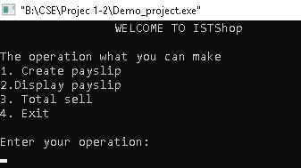

Figure no.1: Home Page

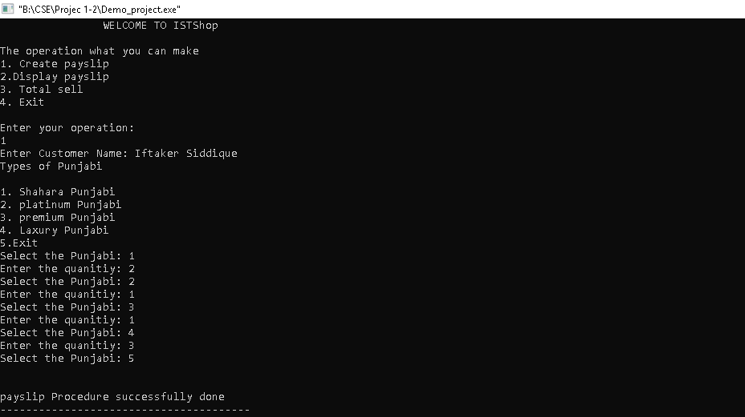

Figure 2: Create Pay-slip

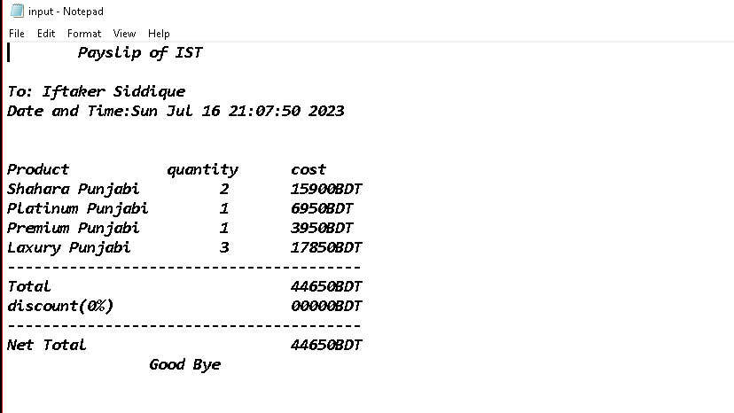

Figure3: Pay-Slip in File

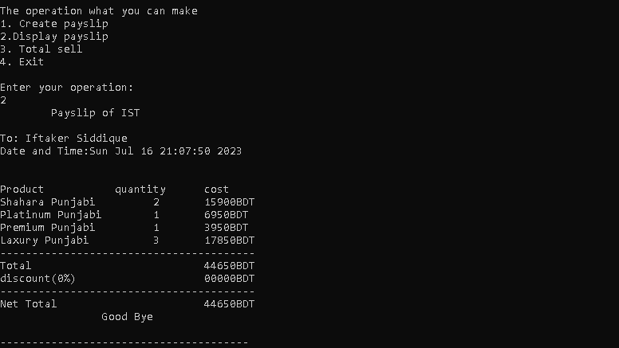

Figure4: Display Pay-slip

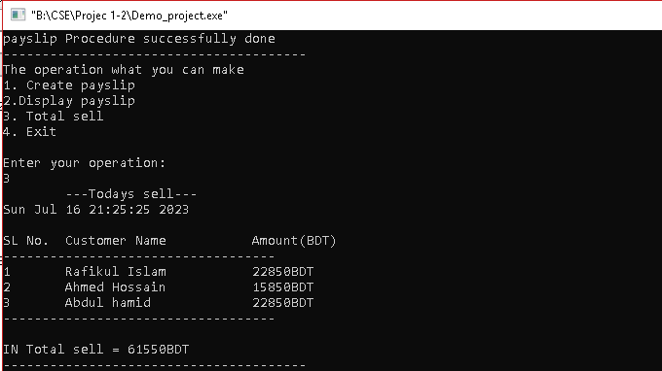

Figure 5: Total Sell of a day

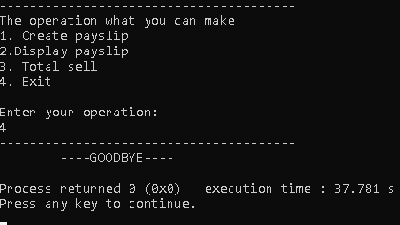

Figure 6: Exit

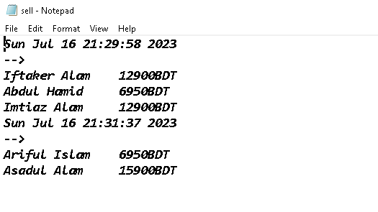

Figure 7: Data of Customer

**CHAPTER 5**

**Test plan**

The testing plan for the "Pay-Slip Project for Customer" aims to ensure the system's functionality, accuracy, security, and user experience. It encompasses various testing types to thoroughly validate the system before deployment. The testing plan includes the following phases:

* 1. **Unit Testing:**
  + Test individual components and functions of the system in isolation.
  + Verify that algorithms for pay-slip generation produce accurate results.
  + Ensure proper handling of edge cases and invalid inputs.

**5.2 Integration Testing:**

* + Validate the integration of different modules within the system.
  + Test the data flow between components and databases.
  + Check for compatibility issues with external systems, if applicable.

**5.3 Functional Testing:**

* + Test all functional requirements defined in the project specifications.
  + Verify the accuracy of pay-slips for various types of transactions.
  + Ensure proper tax calculations, discounts, and total amounts.
  1. **Performance Testing:**
  + Evaluate the system's performance under different loads and traffic conditions.
  + Measure response times for pay-slip generation and delivery.
  + Identify potential bottlenecks and optimize system performance.

**5.5 Compatibility Testing:**

* + Test the system across various web browsers, operating systems, and devices.
  + Ensure that the pay-slips are displayed correctly on different screen sizes.

**5.6 Localization Testing:**

* + Verify the system's compatibility with different languages and locales.
  + Check that pay-slips display localized currency formats and tax information correctly.
  1. **User Acceptance Testing (UAT):**
  + Involve actual users to perform acceptance testing.
  + Gather feedback on the system's usability, functionality, and overall user experience.
  + Address any issues or suggestions raised by users.
  1. **Regression Testing:**
* Perform regression testing after any system updates or changes.
* Ensure that new features do not impact existing functionalities adversely.

By following this testing plan, the "Pay-Slip Project for Shop-to-Customer Transactions" can ensure the system's robustness, reliability, and adherence to requirements before being made available to customers and shop administrators.

**Chapter 6**

**Limitation and Future work**

**6.1 Limitation**

1. **Limited Customization Options:** While the system allows for pay-slip customization, it may have limitations in accommodating highly complex or unique branding requirements of some shops. This could affect the level of personalization desired by certain businesses.
2. **Legal Variations:** Adhering to diverse financial regulations and tax laws across different regions may be challenging. The system may require continuous updates and adjustments to ensure compliance in various jurisdictions, which could impact maintenance efforts.
3. **Data Accuracy and Reliability:** The accuracy of pay-slips depends on the quality and consistency of transaction data. Inaccuracies or discrepancies in transaction records may lead to incorrect pay-slips, potentially affecting customer trust and satisfaction.
4. **Customer Data Privacy Concerns:** Despite implementing strong data security measures, concerns related to customer data privacy may still arise, especially in light of evolving data protection laws and increasing cyber threats.
5. **Limited Historical Data Storage:** While the system may store historical pay-slip data of customers, the storage capacity might be limited, leading to older records being purged over time.
6. **Mobile App Integration Challenges:** If the system is extended to mobile apps, there may be challenges in maintaining consistency across different platforms and ensuring a smooth user experience on various devices.
7. **Cost and Resource Implications:** The development, maintenance, and integration costs of the system might pose challenges for smaller businesses or startups with limited budgets and resources.
8. **User Learning Curve:** Despite efforts to make the user interface user-friendly, some users may still require time and training to become proficient in using the system effectively, potentially leading to a learning curve for shop administrators.

Addressing and mitigating these limitations will be crucial to ensuring the successful implementation and long-term effectiveness of the "Pay-Slip Project for Cusomer” Regular monitoring, user feedback, and iterative improvements can help overcome these challenges and enhance the system's overall performance and user experience.

* 1. **Future Work**

Future work for the "Pay-Slip Project for Customer" involves continuous improvement and expansion to meet evolving needs and technological advancements. Some potential areas for future work include:

* **Enhanced Customization Options:** Introduce more extensive customization features to allow businesses to personalize pay-slips further. This may include customizable layouts, font styles, and additional branding elements to align with each shop's unique identity.
* **Advanced Taxation Handling:** Enhance tax calculation capabilities to accommodate complex tax structures and adapt to changes in tax laws and regulations across different regions.
* **Pay-Slip Analytics:** Implement analytical tools to extract insights from pay-slip data, enabling businesses to identify spending patterns, customer preferences, and potential areas for optimization.
* **Integration with Financial Software:** Explore integration with popular financial management software, enabling customers to seamlessly import pay-slip data for budgeting and financial planning.
* **Feedback Mechanism:** Implement a feedback mechanism to gather input from customers and shop administrators, enabling continuous improvements based on user suggestions and needs.
* **Automated Notifications:** Set up automated notifications to alert customers about pay-slip availability, payment confirmations, and any changes to transaction details.

Continuous research, development, and collaboration with stakeholders will be essential for the successful implementation of these future enhancements. By staying proactive and responsive to user feedback and market demands, the "Pay-Slip Project for Customer" can remain relevant and valuable in the rapidly evolving world of retail and customer-centric services.

**CHAPTER 6**

**CONCLUSIONS**

The "Pay-Slip Project for Customer" marks a significant milestone in transforming the online shopping experience, providing customers with transparent, accurate, and comprehensive pay-slips after every successful transaction. This project aimed to address the limitations of existing e-commerce systems by introducing an efficient and user-friendly pay-slip generation system that enhances customer trust, and ensures compliance with financial regulations.

Through a meticulous development process, the project successfully achieved its primary objectives. The system now generates detailed pay-slips, itemizing product costs, taxes, discounts, and additional charges, empowering customers with a deeper understanding of their transactions. The integration of customization options enables businesses to maintain brand consistency and offer a personalized touch to their customers, enhancing the overall shopping experience.

As with any project, certain limitations were identified, such as the dependency on specific e-commerce platforms, potential data inaccuracies, and the need for continuous compliance updates. However, these challenges will be addressed through future work, embracing advancements in technology and user feedback to further improve the system's capabilities.

In conclusion, the "Pay-Slip Project for Customer" not only represents an essential tool for businesses to build trust and credibility with their customers but also sets the stage for future developments in e-commerce and financial management. By prioritizing transparency, user experience, and data security, the project contributes to a positive and seamless online shopping journey for customers worldwide. As the project evolves, with ongoing enhancements and adaptations, it will continue to play a pivotal role in reshaping the landscape of online retail, reinforcing the bond between businesses and their valued customers.

Top of Form